Git Set credentials

git config --global user.name “PedroJimenez73”

git config --global user.email “[pjimenez@qualitycw.com](mailto:pjimenez@sapienslearning.com)”

git config --global -e (edita con vim, salir con :q)

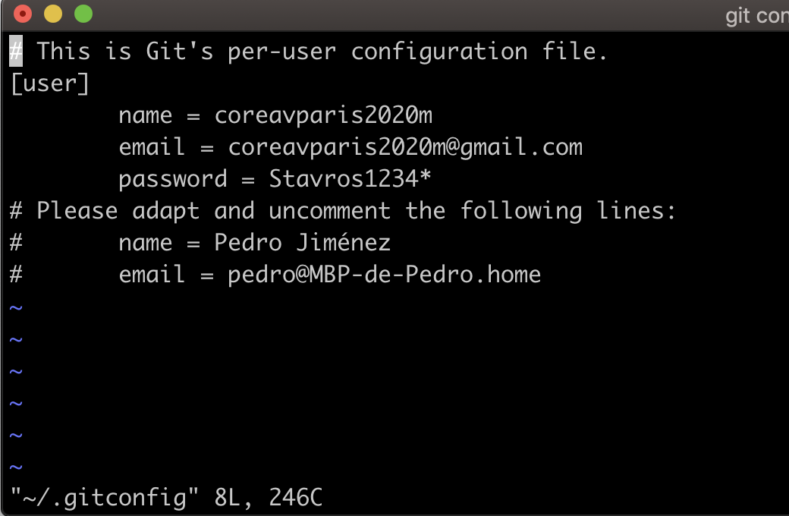

Initializate Git directory

git init

Git estructure

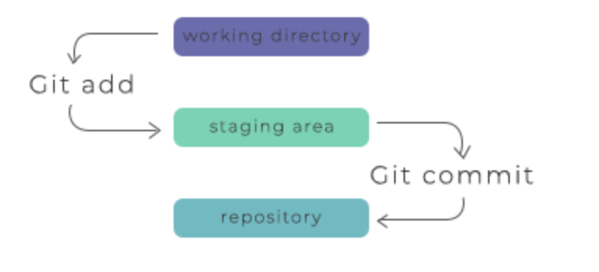

Check git state

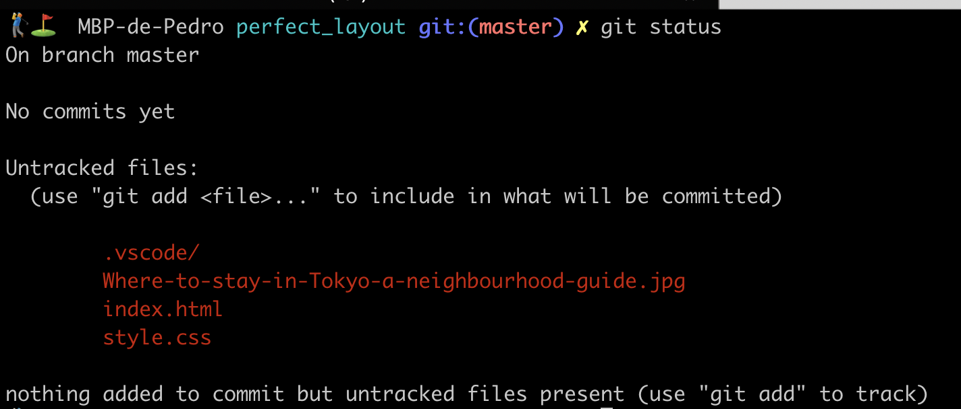

Add all files to git

git add -A (all changes to stage)

or

git add . (all changes to stage except deletions)

or

git add -u (only updated files)

Check again

git status

Set a commit (files state snapshot)

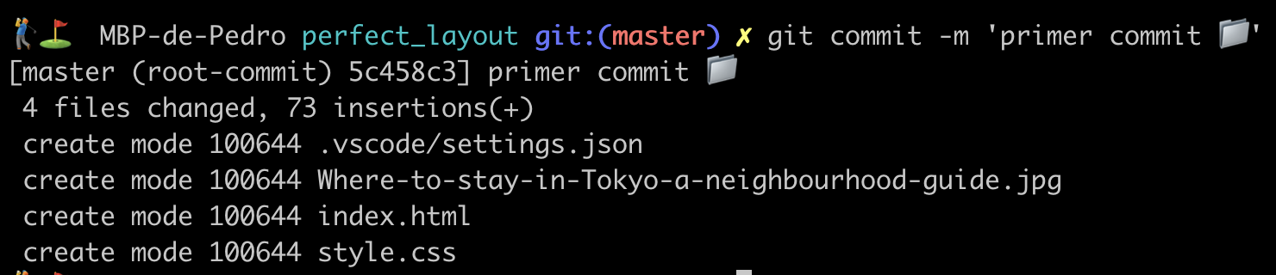

Recover last commit after unexpected changes

Modify any file and delete another one.

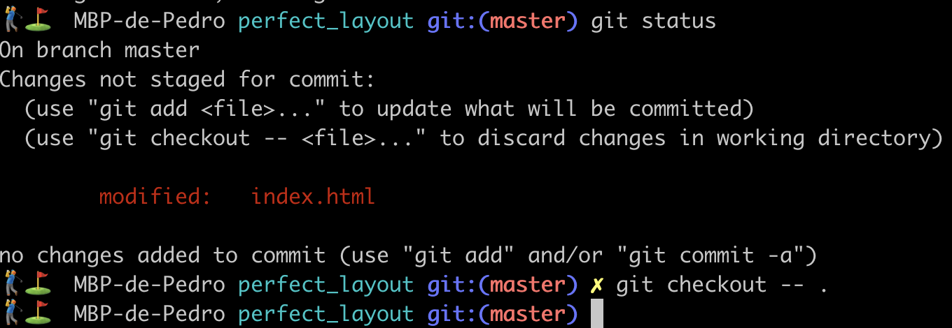

Check out how git recover the modified file.

README.md file

Create a README.md file and add to git

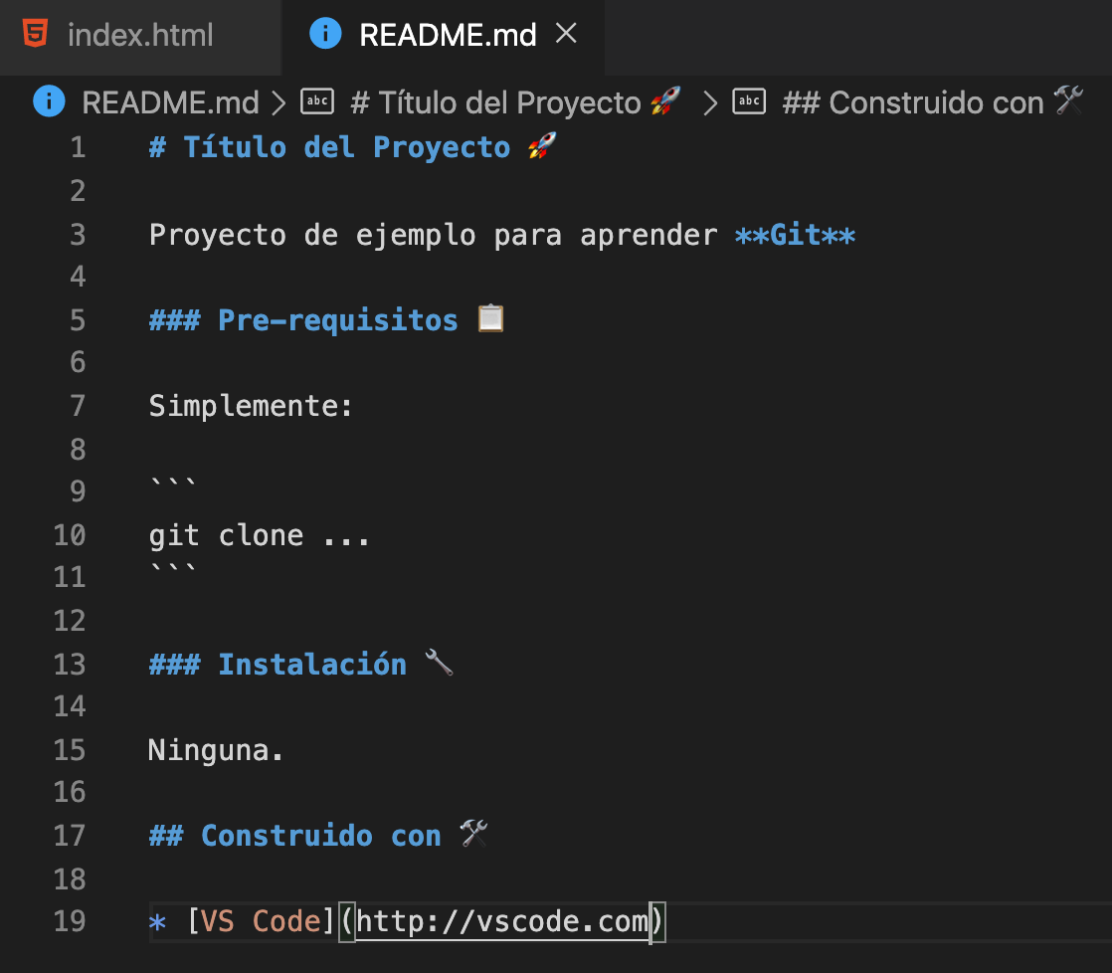

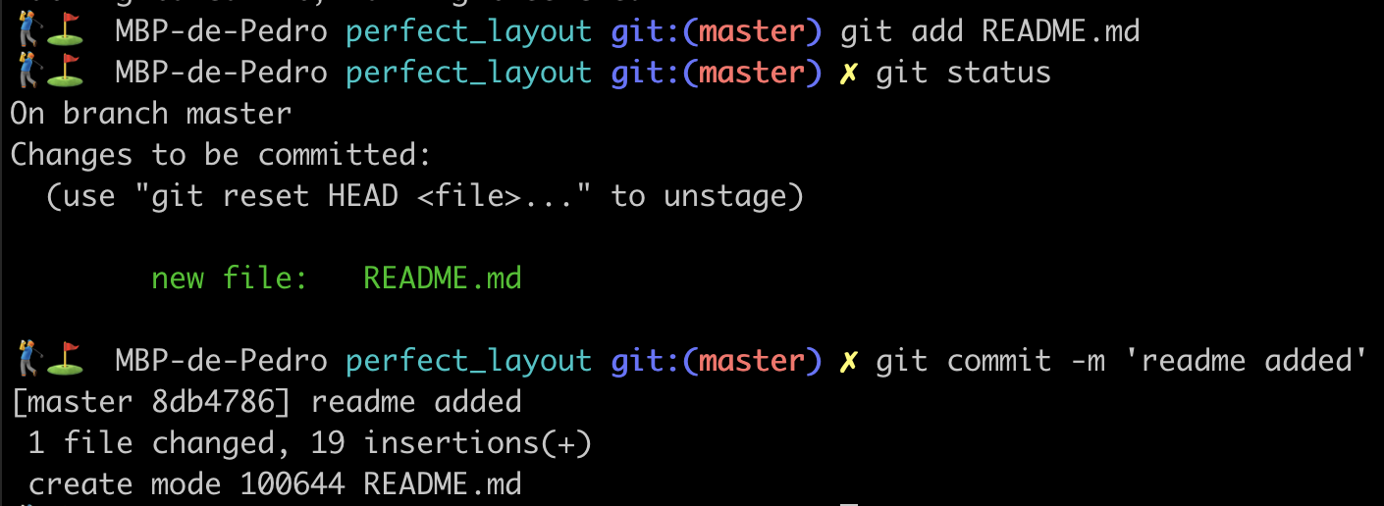

Git status before add

Do several change and git status

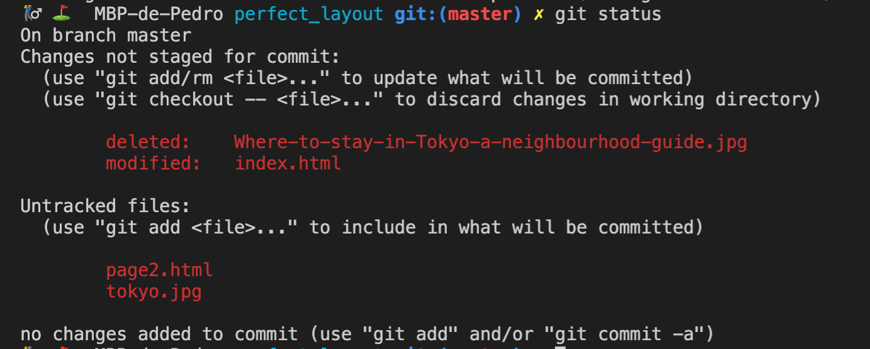

Add only one file

git add page2.html

Add several files by type

git add \*.html

See log commits

git log

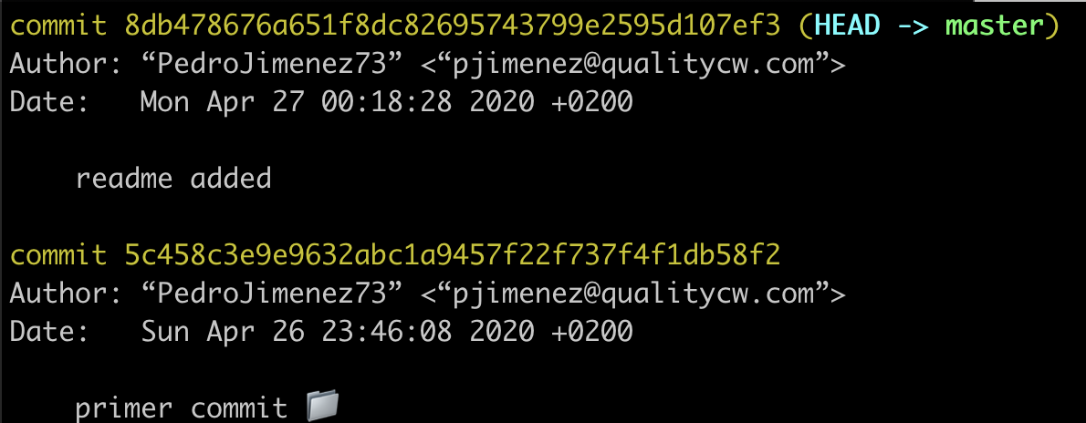

exit with :q

Options

git log --oneline

Global alias

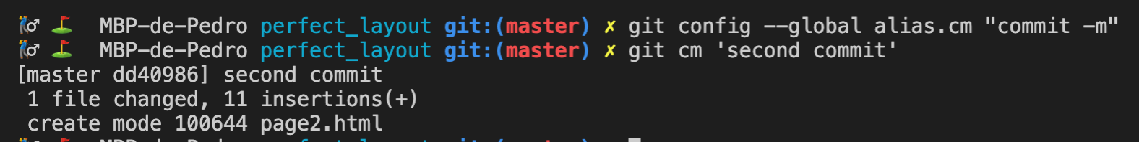

Check with git config --global -l

Remove a file from stage

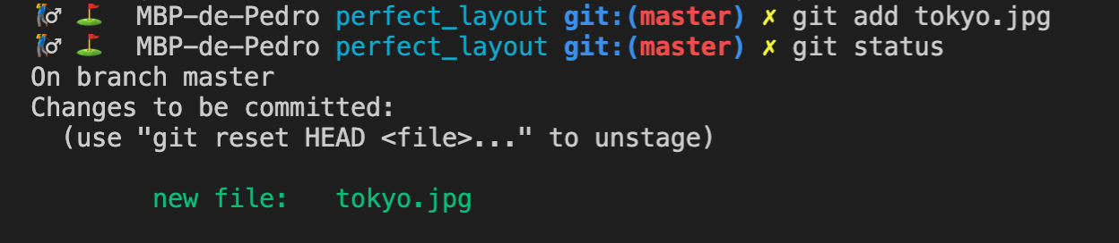

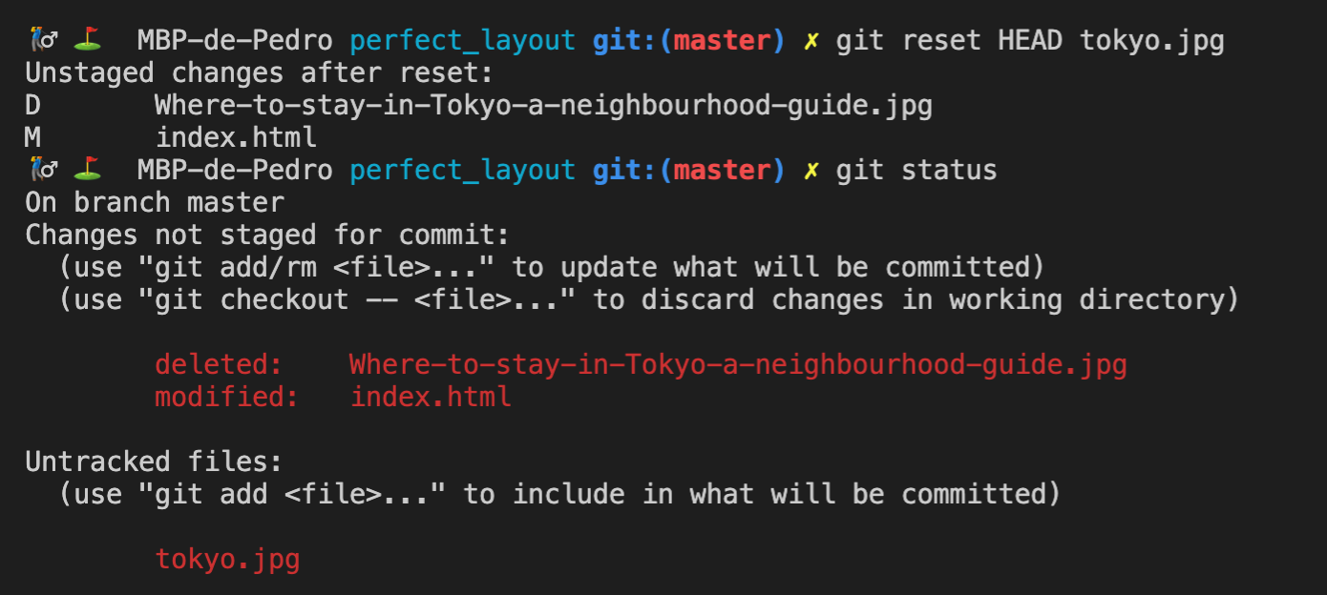

Add updates files and set commit in one step

git commit -am 'lorem...'

Go back to a previous commit

git log --oneline

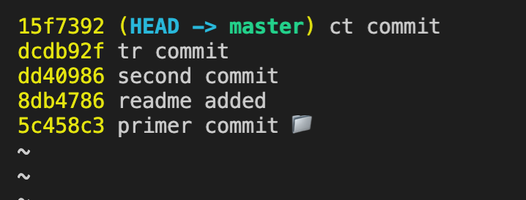

git reset <commit id>

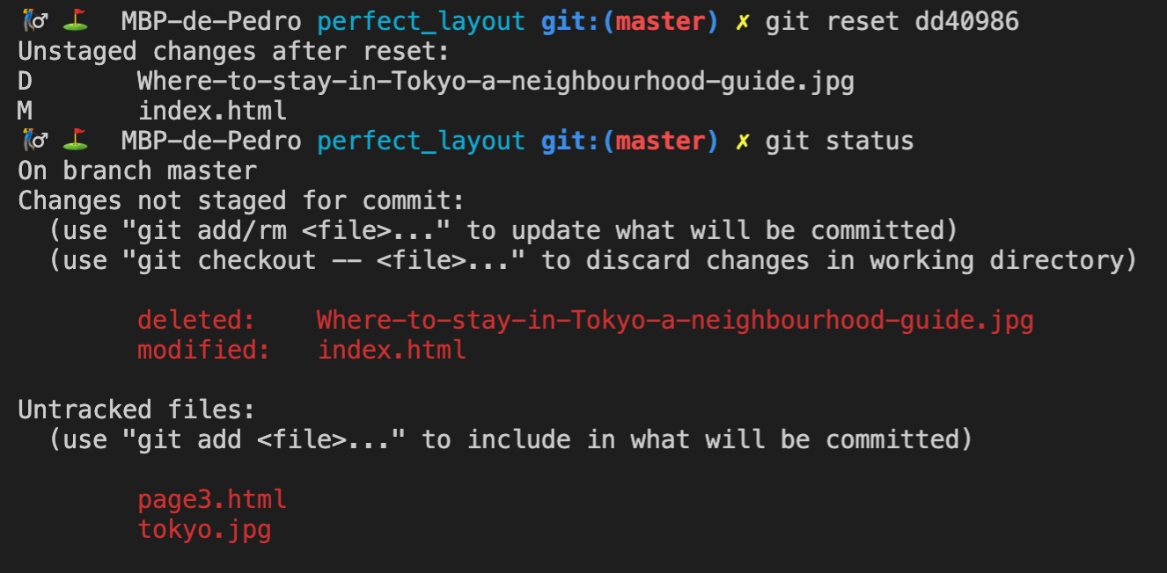

Go back to previous commit and reset changes not staged

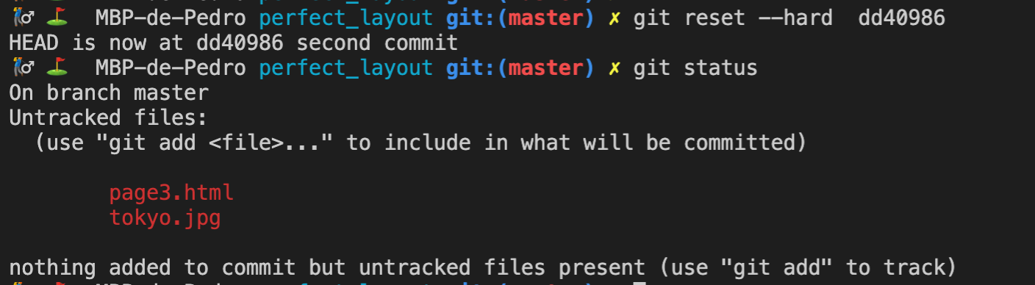

Files not added to commit were not remove.

Repository history

git reflog

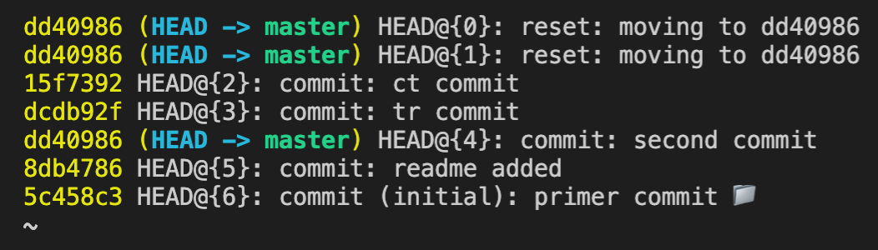

Ignore files

Create a .gitignore file in root and add the files and directories to omit